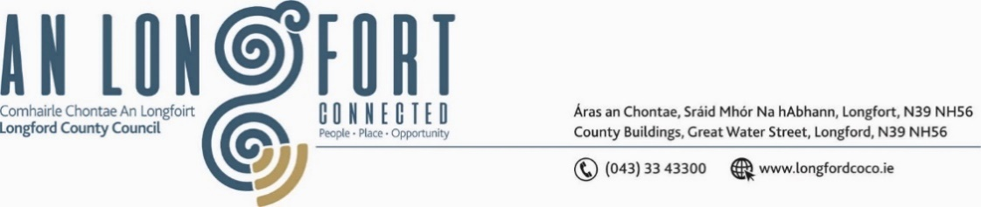

***GRANARD MUNICIPAL DISTRICT***

***Please note meeting will be held in Granard Library.***

**19 June 2023**

**To: Each Member of Granard Municipal District.**

A Chomhairleoir,

You are requested to attend the Annual Meeting of Granard Municipal District to be held in **Granard Library on Tuesday, 27 June 2023 at 3.30pm** to transact business, as set out on the Agenda hereunder.

Mise le meas,

______________

**Claire McNabola,**

**Meetings Administrator.**

**C L A R**

**1**. Election of Cathaoirleach

**2.** Election of Leas Cathaoirleach

**3**. Fix date and time of Granard Municipal District meetings

